**Project Design Phase-II**

**Technology Stack (Architecture & Stack)**

|  |  |
| --- | --- |
| Date | 13 October 2022 |
| Team ID | PNT2022TMID48076 |
| Project Name | REAL TIME RIVER WATER QUALITY MONITORING AND CONTROL SYSTEM |
| Maximum Marks | 4 Marks |

**Technical Architecture:**

The Deliverable shall include the architectural diagram as below and the information as per the table1 & table 2

**REAL TIME RIVER WATER QUALITY MONITORING AND CONTROL SYSTEM**

Guidelines:

1. River water quality can be monitored by the web application.
2. Can be able to know if there are any dust particles present in the water.
3. The PH level of the water can be monitored.
4. Water temperature can be monitored.
5. Alerting the authorities if the water quality is not good so that they can go and announce the localities not to drink that water.

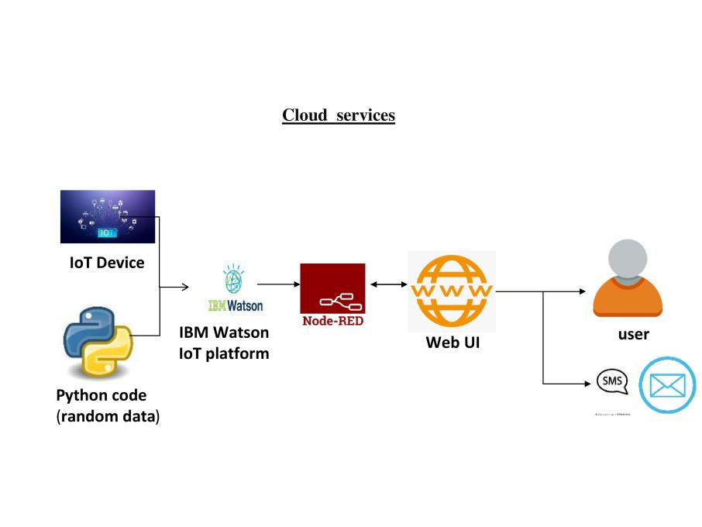

**Table-1 : Components & Technologies:**

|  |  |  |  |
| --- | --- | --- | --- |
| **S.No** | **Component** | **Description** | **Technology** |
|  | User Interface | User interacts with the application through web UI | HTML, CSS, JavaScript / Angular Js / React Js etc. |
|  | Application Logic-1 | Using Arduino uno r3 IOT device connect with various sensors | Java /PYTHON |
|  | Application Logic-2 | Find the ph level and temperature value | Temperature Sensor , ph sensor |
|  | Application Logic-3 | Alerting the authorities if the water quality is not good so that they can go and announce the localities not to drink that water | IBM Watson Assistant |
|  | Database | Data Type can be any format such as arbitrary binary data, text.User-defined blob of data sent from Cloud IoT Core to a device etc. | SQLite |
|  | Cloud Database | Users install software on a cloud infrastructure to implement the database | IBM DB2, IBM Cloudant etc. |
|  | File Storage | Files will be labeled with what they contain and how long they should be kept | IBM Block Storage or Other Storage Service or Local Filesystem |
|  | External API-1 | Purpose of External API used in the device is to use the internet for communicating and conducting allotted operations efficiently | IBM Weather API, etc. |
|  | External API-2 | External API used in the device to expose data that enables those devices to transmit data to your device/mobile, acting as a data interface. | Aadhar API, etc. |
|  | Machine Learning Model | IoT and machine learning deliver insights otherwise hidden in data for rapid, automated responses and improved decision making | Object Recognition Model, etc. |
|  | Infrastructure (Server / Cloud) | Application Deployment on Local System / Cloud  Local Server Configuration:Wearable tech device  Cloud Server Configuration :massive network that supports IoT devices and applications: | Local, Cloud Foundry, Kubernetes, etc. |

**Table-2: Application Characteristics:**

| **S.No** | **Characteristics** | **Description** | **Technology** |
| --- | --- | --- | --- |
|  | Open-Source Frameworks | Monitoring provides the objective  evidence necessary to make sound  decisions on managing water quality  today and in the future. | To assemble data from various sensor  nodes and send it to the base station by  the wireless channel. |
|  | Security Implementations | This application runs on client devices  such as Smart phones, laptops and  desktops.  The root users will be able to generate  daily/monthly/yearly water quality report from data management layer and  visualize in the client devices.  . | Applications can create znode in  zookeeper. Apache HBase is managed by Apache ZooKeeper.  The IOT application will help the users  to visualize the water quality analysis  results produced by the data management layer over different time series continuously |
|  | Scalable Architecture | To develop a system for continuous monitoring  of river water quality at remote places using  wireless sensor networks with low power  consumption, low-cost and high detection  accuracy. | pH, conductivity, turbidity level, etc. are the limits that are analyzed to improve the water quality |
|  | Availability | Using different sensors, this system can  collect various parameters from water,  such as pH, dissolved oxygen, turbidity,  conductivity, temperature, and so on.  The clients can get on going water  quality information from far away. | The rapid development of WSN  technology provides a novel approach to real-time data acquisition, transmission,  and processing |
|  | Performance | To measure water parameters such as pH,  dissolved oxygen, turbidity, conductivity,  etc. us0ing available sensors at a remote  place. | To send SMS to an authorized person  routinely when water quality detected  does not match the pre set standards, so  that, necessary actions can be taken. |